rr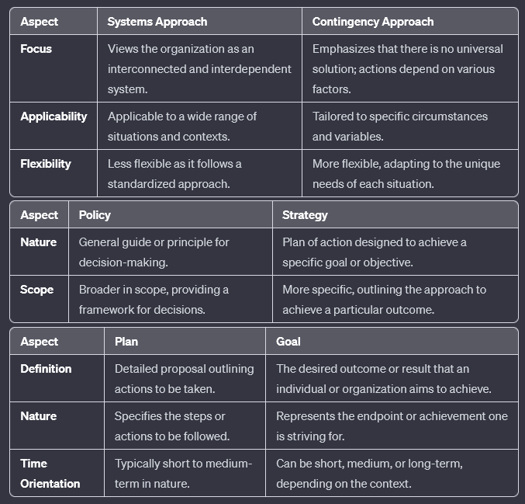

1. **Roles a Manager Needs to Perform in an Organization:**

Managers are responsible for planning, organizing, leading, and controlling. They must set goals, coordinate resources, motivate teams, and ensure efficient operations to achieve organizational objectives.

2. **Planning Premises:**

Planning premises are assumptions about future conditions that serve as a foundation for organizational planning. They guide decision-making by providing a basis for anticipating challenges and opportunities.

3. **Steps in Decision-Making Process:**

Decision-making involves identifying the problem, generating alternatives, evaluating options, making a decision, implementing the choice, and assessing the outcomes in a continuous cycle to ensure effective and informed choices.

4. **Functions of Management:**

The core functions of management include planning (setting goals), organizing (arranging resources), leading (motivating and guiding), and controlling (monitoring and adjusting) to achieve organizational success.

5. **MBO (Management by Objectives):**

MBO is a management approach where organizational goals are collaboratively set and periodically reviewed to align individual and team objectives with overall organizational objectives, fostering a results-oriented culture.

6. **Essential Skills of Managers:**

Essential skills for managers include interpersonal skills for effective communication, decision-making abilities, leadership qualities to inspire and guide teams, and strategic thinking to navigate complex organizational challenges.

7. **Decision-Making Biases and Errors:**

Common decision-making biases and errors include confirmation bias, anchoring bias, overconfidence, groupthink, and availability bias, influencing choices and potentially leading to suboptimal outcomes.

8. **Functions of Management (Reiteration):**

Reiterating, the functions of management involve planning (goal-setting), organizing (resource arrangement), leading (motivation and guidance), and controlling (monitoring and adjustment) to ensure organizational effectiveness.

9. **Define Organization:**

An organization is a structured social entity with a defined hierarchy and coordinated activities, working towards specific goals. It involves the collective efforts of individuals to achieve shared objectives in an efficient and effective manner.

1. **Importance of Departmentalization:**

Departmentalization is crucial for organizational efficiency as it allows for the specialization of tasks, facilitates effective communication and coordination, enhances decision-making, and supports the efficient allocation of resources.

2. **Types of Departmentalization:**

Common types include functional (based on functions like marketing, finance), product-based, customer-based, geographical, and process-based departmentalization.

3. **Hurdles of Effective Communication:**

Barriers to effective communication include noise, language barriers, lack of feedback, cultural differences, and poor choice of communication channels, all of which can impede the accurate and timely exchange of information.

4. **Need for Motivation in an Organization:**

Motivation is essential for fostering employee engagement, increasing productivity, and enhancing job satisfaction. It serves as a driving force behind individual and collective efforts, contributing to overall organizational success.

5. **Purpose of Organizing in Management:**

Organizing in management establishes a structure that clarifies roles, responsibilities, and relationships within an organization. It ensures efficient resource utilization, facilitates coordination, and supports the achievement of organizational objectives.

6. **Illustrate New Organizational Configurations:**

New organizational configurations, such as flat structures, network organizations, and virtual teams, emphasize flexibility, collaboration, and adaptability in response to the dynamic and rapidly changing business environments of the modern era.

1. **Various Senses of Engineering Ethics:**

Engineering ethics encompasses professional conduct, responsibility to society, and the moral implications of technological innovations. It involves considerations of honesty, integrity, and accountability in engineering practices.

2. **Need for Ethics in Engineering:**

Ethics in engineering is crucial to ensure the responsible and sustainable development of technology. It helps engineers make morally sound decisions, prioritizes safety, and addresses societal concerns related to the impact of technological advancements.

3. **Micro-Ethics and Macro-Ethics:**

Micro-ethics pertains to individual conduct and decision-making, while macro-ethics focuses on the broader societal implications of technological choices. For example, an engineer ensuring the accuracy of data in a project (micro) versus considering the environmental impact of a new technology (macro).

4. **Three Most Important Uses of Ethical Theories:**

Ethical theories guide decision-making, provide a framework for evaluating actions, and help in resolving moral dilemmas. They offer normative standards, assist in ethical reasoning, and contribute to creating a just and fair professional environment.

5. **Definition of Safety and its Relation to Risk:**

Safety is the state of being free from harm or danger. It is closely related to risk, as safety measures aim to mitigate or eliminate potential hazards, minimizing the likelihood of harm or adverse events in various engineering applications.

6. **Differing Views of Professionals:**

Professionals may have varying perspectives on ethical considerations, influenced by cultural, personal, or organizational factors. Some may prioritize profit, while others emphasize social responsibility, resulting in differing views on ethical practices within the engineering profession.

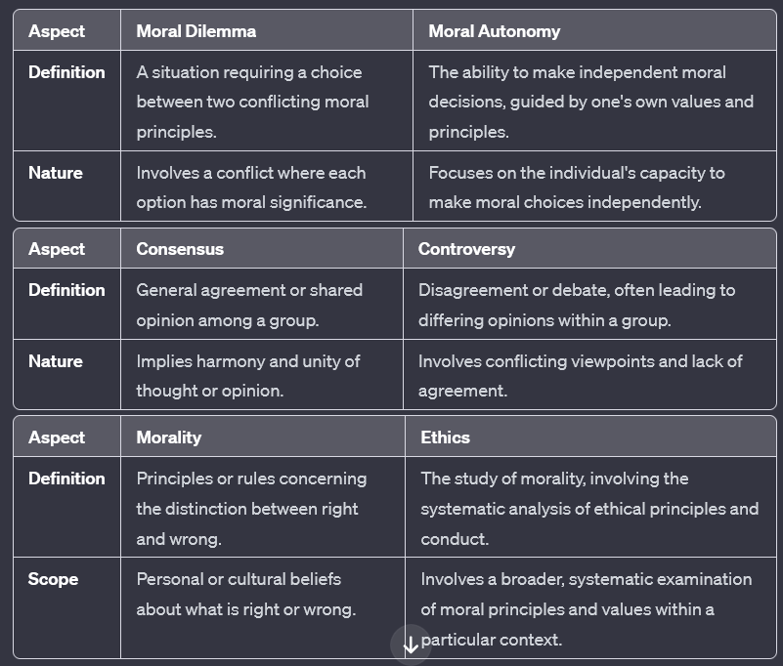

1. **Copyright of a Product:**

Copyright protects the original expression of ideas, such as artistic or literary works, but it doesn't cover the underlying ideas or concepts. In the context of a product, copyright safeguards the specific creative elements, like design or software code, from unauthorized use.

2. **IPR and Its Difference from a Patent:**

Intellectual Property Rights (IPR) encompass various legal rights, including patents. While a patent specifically protects inventions, IPR is a broader term covering patents, copyrights, trademarks, and trade secrets, providing legal recognition and protection for intellectual creations.

3. **Whistle-Blowing and Its Features:**

Whistle-blowing is the act of disclosing information about unethical or illegal activities within an organization to the public or authorities. It often involves an individual (whistleblower) revealing such information in the interest of public welfare, typically facing risks of retaliation.

4. **Internal and External Responsibilities of Engineers:**

Internally, engineers are responsible for ensuring the quality and safety of their work, adhering to ethical standards, and continuous professional development. Externally, they have a duty to the public, clients, and the environment, requiring transparency, honesty, and sustainable practices in their engineering endeavors.

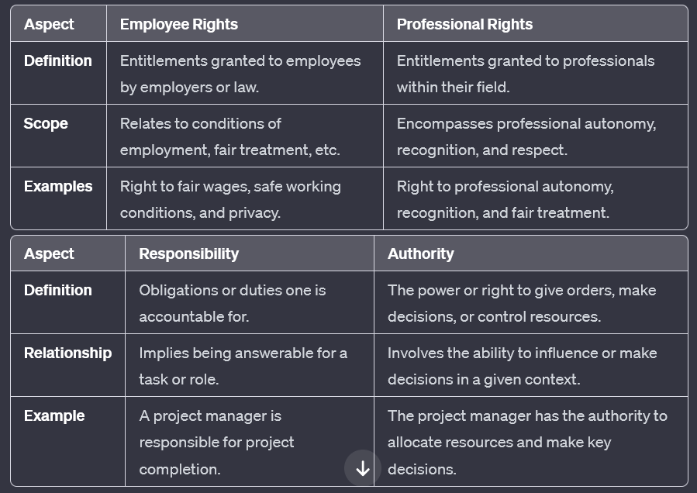

1. **Whistleblowing:**

Whistleblowing is the act of revealing information about unethical or illegal activities within an organization to the public or authorities. It involves an individual, often an employee, coming forward to disclose such information, usually in the interest of public welfare.

2. **Protecting Privacy in Cybersecurity Ethics:**

Protecting privacy in cybersecurity ethics involves implementing measures like encryption, data anonymization, and strict access controls to safeguard individuals' personal information and sensitive data from unauthorized access or disclosure.

3. **Controlling Access Flow in Cybersecurity Ethics:**

Controlling access flow in cybersecurity ethics refers to managing the permissions and restrictions on data access within a system, ensuring that only authorized individuals can access specific information, thereby minimizing the risk of data breaches and unauthorized use.

4. **Cybersecurity Responsibility in an Organization:**

Cybersecurity is not solely the responsibility of the security team in an organization. It involves a collective effort, requiring collaboration between IT professionals, employees, and management to create a robust security culture that addresses potential threats and vulnerabilities comprehensively.

5. **Types of Ethical Frameworks in Cybersecurity:**

Ethical frameworks in cybersecurity include consequentialism (assessing actions based on outcomes), deontology (following moral rules), virtue ethics (emphasizing individual character), and social contract theory (considering agreements and shared norms).

6. **Important Ethical Issues in the Cyber World:**

Ethical issues in the cyber world include privacy concerns, data breaches, cyber warfare, intellectual property theft, and the impact of artificial intelligence on employment and decision-making, highlighting the complex moral landscape surrounding technological advancements.

7. **Access Flow Control in Cybersecurity Ethics:**

Access flow control involves implementing measures like role-based access control (RBAC) and least privilege principle to ensure that individuals only have access to the data and resources necessary for their roles, minimizing the risk of unauthorized access and potential misuse of information.

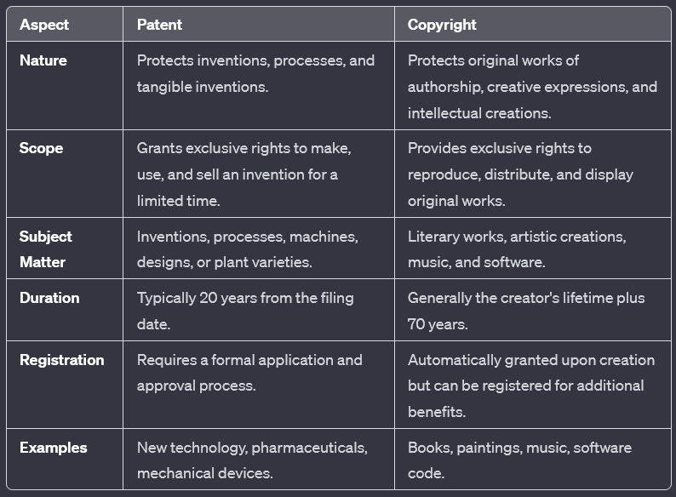

**UNIT 1**

The given question is correctly phrased, but let's provide a more detailed answer:

**Outline of Different Types of Planning in an Organization:**

Planning is a fundamental managerial function that involves anticipating future conditions, setting goals, and determining the course of action to achieve those goals. In an organization, various types of planning are employed to address different aspects and levels of the business. These include:

1. **Strategic Planning:**

- **Definition:** Strategic planning is the highest level of planning that involves setting long-term goals and determining the overall direction of the organization.

- **Purpose:** It helps align the organization with its mission and vision, identifying opportunities and threats in the external environment.

2. **Tactical Planning:**

- **Definition:** Tactical planning is focused on the intermediate term, translating the strategic plan into specific actions and allocating resources to implement them.

- **Purpose:** It outlines the steps necessary to achieve strategic objectives and ensures coordination among different departments.

3. **Operational Planning:**

- **Definition:** Operational planning is concerned with the day-to-day activities required to run the organization effectively.

- **Purpose:** It details the specific tasks, processes, and responsibilities necessary to achieve tactical objectives and contributes to the overall strategic plan.

4. **Contingency Planning:**

- **Definition:** Contingency planning involves preparing for unforeseen events or crises that could impact the organization's ability to achieve its objectives.

- **Purpose:** It ensures the organization can adapt to unexpected challenges, minimizing potential disruptions and ensuring business continuity.

5. **Financial Planning:**

- **Definition:** Financial planning involves projecting the organization's financial needs, budgeting, and resource allocation to meet its goals.

- **Purpose:** It ensures the organization has the necessary financial resources to implement its plans effectively.

6. **Scenario Planning:**

- **Definition:** Scenario planning involves creating alternative future scenarios and planning for each, considering different possibilities.

- **Purpose:** It helps organizations be proactive in addressing potential challenges and opportunities, promoting strategic flexibility.

7. **Strategic Human Resource Planning:**

- **Definition:** This type of planning aligns the organization's human resources with its strategic goals and objectives.

- **Purpose:** It ensures that the workforce is appropriately skilled, motivated, and available to support the achievement of organizational objectives.

In summary, effective planning involves a combination of these different types, ensuring that the organization is well-prepared to navigate a dynamic and complex business environment.

**Is Management a Science or an Art? Discuss:**

The question is correctly phrased. Let's explore the nature of management as both a science and an art in a more detailed manner.

**Management as a Science:**

Management exhibits scientific characteristics as it involves the systematic application of principles, theories, and techniques to achieve organizational goals. Scientific management principles, pioneered by Frederick Taylor, emphasized efficiency, standardization, and the use of data-driven decision-making. Contemporary management practices also draw from fields such as economics, psychology, and sociology, incorporating empirical research and evidence-based strategies.

**Management as an Art:**

On the other hand, management is considered an art due to its creative and intuitive aspects. The application of management principles often requires a unique blend of skills, experience, and judgment that goes beyond standardized procedures. Decision-making, leadership, and interpersonal relations involve subjective elements that rely on the manager's individual creativity and expertise.

**The Synthesis of Science and Art in Management:**

Successful managers often operate at the intersection of science and art, combining systematic approaches with creative solutions. For instance, while scientific principles provide a foundation for planning, organizing, and controlling, the art of management comes into play in the interpretation of data, motivation of individuals, and adaptation to unique organizational challenges.

**Key Aspects of Management as Science and Art:**

1. **Systematic Principles (Science):** Scientific management principles and contemporary theories provide a structured framework for organizational processes.

2. **Creative Application (Art):** Creativity is evident in decision-making, problem-solving, and the innovative approaches managers adopt to address unique challenges.

3. **Objective Methods (Science):** Scientific methods involve data-driven analysis, measurement, and systematic evaluation to enhance efficiency.

4. **Subjective Interpretation (Art):** Artistic aspects involve the subjective interpretation of data, understanding the nuances of human behavior, and tailoring approaches to individual and organizational needs.

**Conclusion:**

In essence, management is a dynamic field that draws from both science and art. The most effective managers recognize the balance between systematic application and creative interpretation, adapting their approach to the ever-changing landscape of organizational challenges and opportunities.

**Explain the Evolution of Management in Detail:**

The evolution of management is a fascinating journey that spans several centuries and reflects the dynamic nature of organizational practices. This evolution can be categorized into different eras, each marked by distinct philosophies, theories, and approaches:

1. **Pre-Industrial Revolution:**

- **Characteristics:** Before the 19th century, management practices were informal, with small-scale operations, family-based businesses, and craft-based production.

- **Focus:** Limited management theories; emphasis on personal relationships and craftsmanship.

2. **Industrial Revolution (Late 18th to Early 19th Century):**

- **Characteristics:** The rise of factories, mass production, and mechanization led to the need for systematic management.

- **Contributions:** **Scientific Management (Frederick Taylor):** Introduced time and motion studies to improve efficiency and productivity.

3. **Classical Era (Late 19th to Early 20th Century):**

- **Characteristics:** A shift towards more formal organizational structures and increased attention to management principles.

- **Contributions:**

- **Administrative Management (Henri Fayol):** Proposed principles of management including planning, organizing, commanding, coordinating, and controlling.

- **Bureaucratic Management (Max Weber):** Emphasized a formalized organizational structure with clear lines of authority and impersonal rules.

4. **Behavioral Era (1930s-1950s):**

- **Characteristics:** Increased focus on human relations and the psychological aspects of management.

- **Contributions:**

- **Hawthorne Studies:** Revealed the impact of social and psychological factors on productivity.

- **Theory of Human Motivation (Abraham Maslow):** Introduced the hierarchy of needs.

5. **Quantitative Era (1950s-1960s):**

- **Characteristics:** Integration of mathematical and statistical methods into management practices.

- **Contributions:**

- **Operations Research:** Applied mathematical techniques to decision-making.

- **Management Information Systems (MIS):** Emergence of technology for information processing.

6. **Contemporary Era (Late 20th Century to Present):**

- **Characteristics:** Embracing diversity, globalization, and a shift toward knowledge-based economies.

- **Contributions:**

- **Total Quality Management (TQM):** Focus on continuous improvement and customer satisfaction.

- **Business Process Reengineering (BPR):** Radical redesign of business processes for efficiency.

7. **Digital Era (21st Century):**

- **Characteristics:** A rapid integration of technology, emphasis on agility, and the rise of virtual organizations.

- **Contributions:**

- **Agile Management:** Adaptive approaches to meet changing market demands.

- **Data Analytics:** Leveraging big data for informed decision-making.

**Conclusion:**

The evolution of management reflects the ongoing quest for effective organizational practices in response to societal, economic, and technological changes. The current era demands a blend of traditional wisdom and innovative strategies to navigate the complexities of the modern business landscape.

**Compare and Contrast Systems Approach and Contingency Approach for International Business:**

**1. Systems Approach:**

- **Definition:** The systems approach views an organization as an interconnected and interdependent system of parts that work together to achieve common goals.

- **Characteristics:**

- Emphasizes holistic thinking and considers the organization as a unified entity.

- Interactions and relationships among components are crucial.

- Changes in one part of the system can affect the entire organization.

- **Application to International Business:**

- In marketing a product built by a startup internationally, the systems approach would involve considering the interconnectedness of various components such as marketing, distribution, and customer support.

- Focus on how changes in one area, such as adapting the marketing strategy, may impact other elements like supply chain or customer relations.

**2. Contingency Approach:**

- **Definition:** The contingency approach suggests that there is no one-size-fits-all solution in management; the optimal approach depends on the specific circumstances or contingencies faced by the organization.

- **Characteristics:**

- Recognizes the need for flexibility in management practices.

- Strategies are contingent upon the unique context and challenges faced.

- No universal principles; solutions depend on situational factors.

- **Application to International Business:**

- Marketing a startup's product internationally under the contingency approach involves adapting strategies based on the specific market conditions, cultural nuances, and regulatory environments.

- Acknowledges that what works in one country or region may not be equally effective in another, and thus, marketing approaches need to be contingent on the local context.

**Comparison:**

1. **Scope:**

- *Systems Approach:* Has a broad scope, considering the organization as a whole.

- *Contingency Approach:* Focuses on specific contingencies or situations.

2. **Flexibility:**

- *Systems Approach:* Less flexible as it emphasizes the unity of the organization.

- *Contingency Approach:* Highly flexible, adjusting strategies based on situational factors.

3. **Predictability:**

- *Systems Approach:* Assumes some level of predictability within the organization.

- *Contingency Approach:* Embraces uncertainty and unpredictability, adapting to unique circumstances.

**Inferences for Marketing a Startup's Product:**

- **Systems Approach:**

- Focus on creating an integrated marketing strategy that aligns with other organizational functions.

- Consider the impact of marketing decisions on the overall system, ensuring harmony in various components.

- **Contingency Approach:**

- Tailor marketing strategies to suit the specific conditions of each international market.

- Embrace flexibility and be ready to modify marketing approaches based on the contingencies faced in different regions.

**Conclusion:**

While the systems approach emphasizes unity and interconnectedness, the contingency approach underscores the need for adaptability and context-specific strategies. When marketing a product built by a startup internationally, a balanced approach that integrates both perspectives is often the most effective, ensuring a comprehensive strategy that considers the global context while adapting to the unique challenges of each market.

**General Administrative Theories of Henri Fayol and Max Weber: Contrasting Ideas**

**1. Henri Fayol's Administrative Theory:**

- **Key Features:**

- **Principles of Management:** Fayol proposed fourteen principles of management, including unity of command, division of work, and scalar chain.

- **Functions of Management:** Identified five key functions – planning, organizing, commanding, coordinating, and controlling.

- **Scalar Chain:** Emphasized a clear hierarchy with a direct line of authority from top to bottom.

- **Unity of Direction:** Stressed the importance of aligning activities towards common organizational goals.

- **Administrative Management:** Fayol focused on the administrative aspect, providing a set of principles applicable to all organizations.

**2. Max Weber's Bureaucratic Theory:**

- **Key Features:**

- **Bureaucracy:** Weber introduced the concept of bureaucracy as an ideal organizational structure.

- **Formal Structure:** Emphasized a formalized organizational structure with clearly defined roles and responsibilities.

- **Impersonal Rules:** Advocated for the use of impersonal rules and regulations to guide organizational actions.

- **Meritocracy:** Supported a merit-based system where positions are filled based on competence rather than personal connections.

- **Legal-Rational Authority:** Introduced the concept of legal-rational authority, where authority is based on rules and regulations.

**Contrasting Ideas:**

1. **Nature of Organization:**

- *Fayol:* Emphasized the universality of management principles applicable to various types of organizations.

- *Weber:* Focused on the ideal bureaucracy, which he saw as the most rational form of organization.

2. **Approach to Hierarchy:**

- *Fayol:* Advocated a clear scalar chain with a single line of authority from top to bottom.

- *Weber:* Also emphasized hierarchy but within a bureaucratic framework, stressing clearly defined roles and levels.

3. **Flexibility:**

- *Fayol:* Less emphasis on flexibility, as his principles aimed at creating a stable and organized structure.

- *Weber:* Allowed for a degree of rigidity in the bureaucratic structure, emphasizing adherence to rules and regulations.

4. **Focus on Personnel:**

- *Fayol:* Considered both technical and human aspects of management, including principles related to interpersonal relations.

- *Weber:* Placed greater emphasis on the formal, legal-rational aspects, with less consideration for personal relationships.

5. **Application:**

- *Fayol:* Principles are broadly applicable across industries and organizational types.

- *Weber:* Bureaucratic principles are more specific and may be challenging to apply in certain modern, dynamic environments.

**Conclusion:**

While both Fayol and Weber contributed significantly to administrative theory, their approaches differed in focus and application. Fayol's principles provided a more flexible and universally applicable framework, while Weber's bureaucratic model offered a more structured but potentially rigid ideal for organizational design. The two theories complement each other, offering insights into different aspects of effective organizational management.

**Explanation of the Classification of Managers:**

The classification of managers involves categorizing individuals based on their roles, responsibilities, and hierarchical positions within an organization. The hierarchical structure typically includes three main levels of management: top, middle, and first-line. Additionally, managers can be classified based on functional areas, levels of authority, and the scope of their responsibilities.

**1. **Top-Level Managers:**

- **Roles and Responsibilities:** Top-level managers, often referred to as executives or senior management, are responsible for making strategic decisions that shape the overall direction of the organization. They set goals, formulate policies, and establish the framework for the entire organization.

- **Titles:** Titles may include Chief Executive Officer (CEO), Chief Operating Officer (COO), President, or Managing Director.

- **Skills:** Require strong leadership, strategic thinking, and decision-making skills.

**2. **Middle-Level Managers:**

- **Roles and Responsibilities:** Middle-level managers act as intermediaries between top-level and first-line managers. They implement the strategies set by top management, coordinate activities within their departments, and communicate both upward and downward in the organizational hierarchy.

- **Titles:** Titles may include General Manager, Regional Manager, or Division Manager.

- **Skills:** Need a mix of leadership, communication, and interpersonal skills.

**3. **First-Line Managers (Front-Line Managers):**

- **Roles and Responsibilities:** First-line managers, also known as supervisors or team leaders, are directly responsible for overseeing the day-to-day operations of a specific work unit or team. They ensure that employees understand their tasks, manage work schedules, and report progress to middle management.

- **Titles:** Titles may include Supervisor, Team Leader, or Department Manager.

- **Skills:** Require strong organizational, communication, and problem-solving skills.

**4. **Functional Classification:**

- **Roles and Responsibilities:** Managers can also be classified based on the functional areas they oversee, such as marketing, finance, human resources, operations, or information technology.

- **Titles:** Titles may include Marketing Manager, Finance Manager, HR Manager, Operations Manager, or IT Manager.

- **Skills:** Require specialized knowledge related to their functional area.

**5. **Levels of Authority:**

- **Roles and Responsibilities:** Managers can be classified based on the levels of authority they possess, such as line managers with direct authority over subordinates or staff managers who provide support and expertise but have limited direct authority.

- **Titles:** Titles vary based on their roles within the organization.

- **Skills:** Line managers need strong leadership and decision-making skills, while staff managers require expertise in their functional areas.

**6. **Scope of Responsibilities:**

- **Roles and Responsibilities:** Managers can be classified based on the scope of their responsibilities, distinguishing between generalists who oversee a broad range of functions and specialists who focus on specific areas.

- **Titles:** Titles may vary based on the specific roles they undertake.

- **Skills:** Generalists need a diverse skill set, while specialists require in-depth expertise.

**Conclusion:**

The classification of managers is crucial for understanding their roles, responsibilities, and contributions within an organization. This categorization helps create a clear organizational structure, ensuring effective coordination and management across various levels and functional areas.

**UNIT 2**

Analyze the given situation and derive your inference about what could be done to prevent this from happening? A doctor discharged a staff member who had been working for him For nine months. She then claimed that her civil rights were violated and that she was discriminated against because of her age. She was 46 years old. During an investigation, the doctor was asked to provide copies other performance evaluations to justify the contention that the discharge was based on her performance, not her age. No performance valuations were given to any employees. This claim led to an out-of-court settlement. Considerations The employee had been with the doctor for nine months and had not received a performance appraisal. She claimed that she was not aware that her performance was not satisfactory and was surprised when she was terminated. She alleged that the sole reason for her discharge was her age — that the doctor wanted to hire a younger person. The doctor said she had been warned on several occasions, but nothing had been documented. This is not an isolated incident: such claims are made against doctors every day.

**Analysis of the Situation and Recommendations for Prevention:**

**Situation Analysis:**

A doctor discharged a staff member who had been working for him for nine months. The discharged employee, aged 46, claimed her civil rights were violated, alleging age discrimination. During an investigation, the doctor could not provide performance evaluations, and the case resulted in an out-of-court settlement. The employee was unaware of her performance issues, and the doctor had not documented warnings.

**Key Issues:**

1. Lack of Performance Evaluations: The absence of performance evaluations created ambiguity regarding the employee's performance and contributed to the legal claim.

2. Allegations of Age Discrimination: The discharged employee claimed age discrimination, alleging that the doctor aimed to replace her with a younger person.

3. Lack of Documentation: The doctor had not documented warnings given to the employee, making it challenging to justify the termination based on performance issues.

**Recommendations for Prevention:**

1. **Implement Regular Performance Evaluations:**

- **Action:** Establish a systematic process for conducting regular performance evaluations for all employees.

- **Rationale:** Regular evaluations provide a clear understanding of employee performance, identify areas for improvement, and create a documented record of performance.

2. **Document Performance Issues and Warnings:**

- **Action:** Implement a formal system for documenting performance issues and any warnings given to employees.

- **Rationale:** Documentation serves as evidence in case of disputes, helping to justify employment decisions and providing a clear history of performance-related discussions.

3. **Provide Training on Anti-Discrimination Policies:**

- **Action:** Conduct training sessions for all employees, including managers, on anti-discrimination policies and procedures.

- **Rationale:** Ensuring that all staff members are aware of and understand anti-discrimination policies can help prevent discriminatory practices and contribute to a fair and inclusive work environment.

4. **Establish Clear Termination Procedures:**

- **Action:** Develop clear and transparent procedures for employee terminations, ensuring that documentation, warnings, and justifications are consistently maintained.

- **Rationale:** Clearly defined termination procedures help prevent legal disputes and contribute to fair and ethical employment practices.

5. **Maintain Open Communication Channels:**

- **Action:** Foster open communication between employees and management to address concerns and provide feedback.

- **Rationale:** Open communication can help employees understand their performance expectations, receive constructive feedback, and address potential issues before they escalate.

6. **Seek Legal Guidance:**

- **Action:** Consult with legal professionals to ensure that employment practices comply with relevant laws and regulations.

- **Rationale:** Legal guidance can help identify potential areas of risk, ensure compliance with anti-discrimination laws, and provide guidance on best practices.

**Conclusion:**

To prevent situations similar to the one described, implementing regular performance evaluations, documenting performance-related issues, providing anti-discrimination training, establishing clear termination procedures, maintaining open communication, and seeking legal guidance are essential steps. These measures contribute to a fair and transparent workplace, reducing the risk of legal claims and fostering a positive work environment.

**UNIT 3**

**Outline of Various Senses of Responsibility:**

Responsibility is a multifaceted concept that encompasses different dimensions and perspectives. The various senses of responsibility can be categorized into individual responsibility, social responsibility, professional responsibility, and moral responsibility.

1. **Individual Responsibility:**

- **Definition:** Individual responsibility pertains to the obligations and duties that an individual has in personal and private contexts.

- **Characteristics:**

- Personal Choices: It involves taking ownership of personal choices, actions, and decisions.

- Self-Accountability: Individuals are responsible for their own well-being, development, and fulfillment of personal goals.

- Self-Reflection: It encourages self-reflection to understand one's impact on personal and interpersonal relationships.

2. **Social Responsibility:**

- **Definition:** Social responsibility extends responsibility beyond the individual to encompass obligations to the broader society and community.

- **Characteristics:**

- Civic Engagement: Involves active participation in community and civic activities for the greater good.

- Environmental Stewardship: Encourages responsible actions towards the environment and sustainable practices.

- Philanthropy: Includes contributing time, resources, or expertise to charitable causes and community development.

3. **Professional Responsibility:**

- **Definition:** Professional responsibility relates to the duties and ethical obligations associated with one's role or profession.

- **Characteristics:**

- Ethical Conduct: Requires adherence to ethical standards and codes of conduct within a professional domain.

- Competence: Encompasses maintaining and enhancing professional competence through continuous learning.

- Client or Customer Focus: Involves prioritizing the interests and well-being of clients or customers.

4. **Moral Responsibility:**

- **Definition:** Moral responsibility centers around ethical considerations and adherence to a set of moral principles.

- **Characteristics:**

- Upholding Values: Involves aligning actions with personal or societal values.

- Consideration for Others: Encourages empathetic and compassionate behavior towards others.

- Ethical Decision-Making: Requires making decisions that are morally justifiable and socially acceptable.

5. **Organizational Responsibility:**

- **Definition:** Organizational responsibility refers to the duties and obligations of entities, such as businesses, institutions, or governments.

- **Characteristics:**

- Corporate Social Responsibility (CSR): Involves businesses contributing to societal well-being and environmental sustainability.

- Legal Compliance: Entails adhering to laws and regulations governing the organization's operations.

- Stakeholder Relations: Emphasizes maintaining positive relationships with various stakeholders, including employees, customers, and the community.

**Conclusion:**

The various senses of responsibility collectively contribute to fostering a well-rounded and ethically conscious individual, professional, and societal member. Recognizing and acting upon these different dimensions of responsibility can lead to more accountable and sustainable practices in both personal and organizational contexts.

**Senses of Responsibility:** (PDF answer )

1. **Responsibility is a Moral Virtue:**

- **Explanation:** In this sense, responsibility is considered a moral virtue, reflecting an individual's commitment to ethical conduct and fulfilling their obligations. It goes beyond mere compliance with rules, emphasizing a personal commitment to act ethically and conscientiously.

- **Implication:** Individuals embodying responsibility as a moral virtue are driven by an internalized sense of duty, seeking to contribute positively to society and uphold moral principles in their actions.

2. **Responsibility is Moral Obligation:**

- **Explanation:** This perspective views responsibility as a moral obligation, emphasizing a duty-bound commitment to behave ethically and fulfill one's obligations to others. It implies a sense of duty and accountability toward moral standards and societal expectations.

- **Implication:** Individuals recognizing responsibility as a moral obligation feel compelled to act ethically not only for personal integrity but also as a commitment to meeting the expectations of a broader moral framework.

3. **Responsibility is About General Moral Capacities of People:**

- **Explanation:** This perspective posits that responsibility is rooted in the general moral capacities of individuals. It suggests that people, by virtue of their moral sensibilities, possess the capacity to recognize and fulfill responsibilities.

- **Implication:** The emphasis on general moral capacities implies that responsibility is not limited to specific roles or contexts but is inherent to human nature, requiring individuals to exercise moral judgment and responsibility in various aspects of their lives.

4. **Responsibility Means Accountability and Liability for Actions:**

- **Explanation:** Responsibility, in this sense, is closely linked to accountability and liability for one's actions. It implies that individuals are answerable for the consequences of their choices and behaviors.

- **Implication:** This perspective underscores the importance of consequences in shaping responsible behavior. Individuals who understand responsibility as accountability recognize the need to consider the potential impact of their actions on others and on the broader community.

5. **Responsibility Means Blameworthiness:**

- **Explanation:** Viewing responsibility as blameworthiness suggests that individuals can be held accountable for their actions, especially when those actions lead to negative consequences or harm.

- **Implication:** This perspective introduces an ethical dimension to responsibility, acknowledging that individuals may be subject to praise or blame based on the moral evaluation of their choices. Blameworthiness implies a moral assessment of whether an individual's actions align with ethical standards.

In summary, the senses of responsibility encompass moral virtue, obligation, general moral capacities, accountability, and blameworthiness. These perspectives highlight the multifaceted nature of responsibility, indicating that it involves internalized ethical principles, a commitment to fulfilling duties, inherent moral capacities, awareness of consequences, and the acknowledgment of ethical evaluations in assessing one's actions. Understanding responsibility in these varied dimensions contributes to a comprehensive view of ethical behavior and personal integrity.

Interpret the following scenario and give your opinion to prevent this from happening.

A doctor terminated a female staff member who had been working for him for nine months.

She then claimed that her civil rights were violated and that she was discriminated because

of her age. She was 46 years old. During an investigation, the doctor was asked to provide

copies of her performance evaluations to justify the contention that the termination was based on her performance, not her age. However, no performance evaluations had been done to any

employees. This claim led to an out-of-court settlement.

Considerations

The employee had been working with the doctor for nine months and had not received a

performance appraisal. She claimed that she was not aware that her performance was not

satisfactory and was surprised when she was terminated. She alleged that the sole reason for

her termination was her age

— that the doctor wanted to hire a younger person. The doctor

said she had been warned on several occasions but nothing had been documented.

**Interpretation of the Scenario and Recommendations for Prevention:**

**Scenario Interpretation:**

In the given scenario, a doctor terminated a female staff member after nine months of employment. The terminated employee, aged 46, claimed her civil rights were violated, alleging age discrimination. During the investigation, the doctor could not provide performance evaluations, leading to an out-of-court settlement. The employee, unaware of performance issues, alleged termination based solely on age, while the doctor claimed verbal warnings were given but not documented.

**Analysis and Recommendations:**

1. **Establish Clear Performance Evaluation Procedures:**

- **Recommendation:** Implement a formal and systematic performance evaluation process for all employees, ensuring regular assessments of job performance.

- **Rationale:** Clear performance evaluations provide documented evidence of an employee's strengths, areas for improvement, and overall contribution to the organization. This practice ensures fairness and transparency.

2. **Document Performance Warnings and Feedback:**

- **Recommendation:** Encourage managers to document verbal warnings and feedback provided to employees, creating a paper trail of performance-related discussions.

- **Rationale:** Documenting warnings and feedback helps in justifying employment decisions, especially in cases of disputes, and ensures consistency in the application of workplace policies.

3. **Provide Training on Anti-Discrimination Policies:**

- **Recommendation:** Conduct regular training sessions for all employees, including management, on anti-discrimination policies, emphasizing fair employment practices.

- **Rationale:** Training promotes awareness of legal and ethical obligations, reducing the likelihood of discriminatory actions and fostering an inclusive workplace culture.

4. **Implement Transparent Termination Procedures:**

- **Recommendation:** Develop clear and transparent procedures for employee terminations, emphasizing documentation and justifiable reasons for employment decisions.

- **Rationale:** Transparent termination procedures contribute to fair and ethical practices, minimizing the risk of legal claims and ensuring accountability in employment decisions.

5. **Encourage Open Communication Channels:**

- **Recommendation:** Foster an open communication environment where employees feel comfortable discussing performance concerns and seeking clarification on expectations.

- **Rationale:** Open communication helps prevent misunderstandings, ensures that employees are aware of their performance status, and provides an opportunity for improvement.

6. **Legal Consultation and Compliance:**

- **Recommendation:** Seek legal consultation to ensure that termination procedures comply with relevant employment laws and regulations.

- **Rationale:** Legal guidance helps identify potential risks, ensures compliance with anti-discrimination laws, and provides insights into best practices for employment-related decisions.

**Conclusion:**

To prevent scenarios like the one described, organizations should prioritize transparent and documented performance evaluations, establish clear termination procedures, provide anti-discrimination training, and maintain open communication channels. These practices contribute to a fair and ethical workplace, reducing the risk of legal disputes and promoting a positive organizational culture.



Rajiv is an IAS aspirant. He studied in two premier institutions and worke or a w e In an IT company. He quit the job and started preparing for the civil services exams. In his first attempt he wrote mains but could not qualify for the personality test. In next two attempts. however. he gave interviews but fate had it that his name did not appear in the final list. In all three attempts he had scored less in Mains and in two interviews his score was average it' not bad. Coming under General Merit, Rajiv had only four attempts to get into IAS. For the last attempt, he decided to take a break of one year and prepare extremely well giving no chance to fate. By then he had spent five years just for preparing for this exam with no job in hand. He did prepare well and easily sailed through the Preliminary and Mains exam. For his final interview, Rajiv. prepared himself very well. He read widely. He contacted his peers and well wishers. talked to them extensively and took feedback on his body language :and communication skills. He took mock tests at prominent institutions and got a very positive feedback. His confidence was at an all time high. By the time interview call letter came. Rajiv was fully ready to face his final test to realize the dream of becoming an IAS officer. On the previous day of his interview. Rajiv talked to his parents. girlfriend and teachers and sought their wishes. He had a sound sleep too. His interview was scheduled in the second session i.e. in the afternoon. On the day of his interview. in the morning Rajiv was calm. composed and had a friendly chat with fellow aspirants who had stayed together in a friend's room. He had his lunch and left room in his bike half an hour before the scheduled time Of his appearance at UPSC office. Rajiv was riding his bike with lots of thoughts in his mind. The road was almost empty. As he was riding. just in front of him, a speeding bike collided with the road divider. Seeing this. Rajiv stopped his bike for a minute and went near the accident scene. A man, crying with pain was lying in a pool of blood and a girl child, around 5 year Old, was lying unconscious next to the man. Rajiv looked around for help, but two or three cars sped away without stopping by. Rajiv had to be at UPSC office in IO minutes. If not he would forever lose his dream of becoming an IAS officer. In this situation. how Raiiv could deal with moral dilemma? Analyse and justify our answer.

**Analysis of Rajiv's Moral Dilemma:**

Rajiv, an IAS aspirant, faced a moral dilemma when he witnessed a road accident on the day of his final interview. This situation presented conflicting obligations between his personal ambition to become an IAS officer and the ethical responsibility to assist the injured individuals. Analyzing Rajiv's moral dilemma involves considering the ethical principles at play and the potential consequences of his decision.

**1. Ethical Principles:**

- **Duty to Help:** The ethical principle of duty to help suggests that individuals have a moral obligation to assist those in need, especially in emergency situations.

- **Personal Ambition:** Rajiv's ambition to become an IAS officer is a personal goal that is not inherently unethical, but it conflicts with the immediate duty to help the accident victims.

**2. Potential Consequences:**

- **Helping the Injured:** If Rajiv stops to help the injured individuals, it could lead to delays in reaching the UPSC office for his interview. However, he would fulfill his duty to assist those in distress.

- **Prioritizing the Interview:** If Rajiv chooses to prioritize the interview and continue on his way without helping, he may reach the UPSC office on time, but it would come at the expense of neglecting his duty to help.

**Justification of Decision:**

Rajiv's decision in this moral dilemma depends on his values, priorities, and the weight he assigns to each obligation. Several factors may influence his decision:

1. **Time Sensitivity:**

- If Rajiv assesses the severity of the accident and believes that immediate assistance is critical for the well-being of the injured, he may prioritize stopping to help.

2. **Emergency Services:**

- Rajiv could call emergency services while providing initial assistance, minimizing the delay and ensuring professional help arrives promptly.

3. **Personal Values:**

- If Rajiv places a high value on compassion, social responsibility, and ethical conduct, he may be inclined to prioritize helping the injured over his immediate personal ambitions.

4. **Long-Term Perspective:**

- Rajiv may consider the long-term implications of his decision. Prioritizing immediate personal goals at the expense of ethical responsibilities could impact his character and reputation.

**Possible Decision and Justification:**

Given the gravity of the situation, Rajiv may choose to stop and provide immediate assistance to the injured individuals. While this decision might result in a delay for his interview, the ethical duty to help in an emergency takes precedence. Rajiv could explain the situation to the UPSC authorities, emphasizing the moral dilemma he faced and his commitment to ethical conduct. This transparent communication may be viewed favorably by the interview panel, recognizing his integrity and commitment to societal values.

**Conclusion:**

Moral dilemmas test an individual's ability to balance personal aspirations with ethical responsibilities. Rajiv's decision should align with his values and the ethical principles he holds dear. In navigating this moral dilemma, Rajiv has an opportunity to demonstrate not only his competence but also his integrity and commitment to the well-being of others—a quality that is highly valued in public service roles such as the IAS.

**Models of Professional Engineers:**

1. **Savior Model:**

- **Description:** In the Savior model, the engineer is perceived as a societal redeemer, capable of addressing and resolving significant challenges such as poverty, inefficiency, waste, and manual labor.

- **Role:** Engineers under this model are seen as individuals with the skills and knowledge to bring about positive transformations, improving the overall well-being of society.

- **Responsibilities:** The engineer as a savior takes on the responsibility of leading initiatives that contribute to societal progress and welfare. This may involve designing innovative solutions, implementing projects, and advocating for positive change.

2. **Guardian Model:**

- **Description:** Engineers, as guardians, are recognized for their expertise in guiding the direction and pace of technological development.

- **Role:** This model positions engineers as stewards of technological progress, responsible for ensuring that advancements align with ethical, environmental, and societal considerations.

- **Responsibilities:** Engineers act as custodians of responsible innovation, assessing the impact of technology on society, and influencing its trajectory to ensure positive outcomes.

3. **Bureaucratic Servant Model:**

- **Description:** In the bureaucratic servant model, the engineer is characterized as a loyal organizational member who utilizes specialized skills to solve problems within the established structure.

- **Role:** Engineers operate within bureaucratic frameworks, applying their technical expertise to address challenges and contribute to organizational objectives.

- **Responsibilities:** The engineer's role involves problem-solving, task execution, and adherence to organizational policies and procedures. Their contributions are focused on enhancing efficiency and effectiveness within the established bureaucratic context.

4. **Social Servant Model:**

- **Description:** Engineers, in cooperation with management, are tasked with receiving societal directives and fulfilling society's desires.

- **Role:** Engineers are intermediaries between society and organizations, interpreting societal needs and aligning engineering projects with broader social goals.

- **Responsibilities:** Engineers in the social servant model work collaboratively with stakeholders to understand societal expectations, incorporate ethical considerations, and ensure that engineering projects contribute positively to the well-being of communities.

5. **Social Enabler and Catalyst Model:**

- **Description:** This model positions engineers as enablers and catalysts for social change, recognizing their role in facilitating positive transformations.

- **Role:** Engineers are seen as agents of change who leverage their skills to enable societal progress, acting as catalysts for innovation, inclusivity, and sustainable development.

- **Responsibilities:** Engineers actively engage with communities, promoting inclusivity, sustainable practices, and social innovation. They seek to enable positive change by applying their technical expertise in collaboration with diverse stakeholders.

6. **Game Player Model:**

- **Description:** The game player model acknowledges the dynamic and competitive nature of the engineering profession, where engineers navigate challenges as strategic players.

- **Role:** Engineers in this model are strategic thinkers who understand the competitive landscape and adapt to changing circumstances in the engineering field.

- **Responsibilities:** Engineers as game players embrace agility, continuous learning, and strategic decision-making. They navigate complexities, seek opportunities, and thrive in a competitive environment.

Each model reflects a distinct perspective on the role of professional engineers in society, emphasizing different aspects of their responsibilities, relationships, and impact. These models underscore the diverse and multifaceted nature of the engineering profession, recognizing engineers as contributors to societal well-being, guardians of ethical innovation, organizational servants, and catalysts for positive change.

**UNIT 4 :**

Dr. Ramerio is a leading researcher in her field. She oversees a laboratory with 5 full-time employees and three graduate assistants. She has been given funding to create a position for a laboratory manager. The responsibilities of the manager position include overseeing the budget, developing operating procedures. scheduling work, ordering supplies, and taking care of personnel matters. Dr. Ramerio would like to hire her husband in this position. To avoid issues of nepotism, she asked her colleague, who is also the assistant department head. to chair the search committee and to recommend the top candidate to the department head. The top candidate turns out to Dr.Ramerio's husband. Dr. Ramerio is not involved with the search committee and does not interview any of the candidates. "Ille department head approves the hiring of her husband. Again, to avoid violating the nepotism policy. the responsibility for evaluating and recommending salary increases for her husband is delegated to the assistant department head. Examine the given scenario and infer whether there is contlict of interest. Justify our answer'?

**Analysis of Conflict of Interest in the Given Scenario:**

The scenario involves Dr. Ramerio, a leading researcher, overseeing a laboratory and seeking to hire her husband for a newly created laboratory manager position. The process includes measures to avoid nepotism, such as having a colleague chair the search committee and delegating salary evaluations to the assistant department head. However, the situation raises concerns about potential conflicts of interest. Let's examine the key elements and justify whether a conflict of interest exists.

**1. Nepotism and Hiring Process:**

- **Concern:** Dr. Ramerio wishes to hire her husband for the laboratory manager position, which could be perceived as nepotism, favoring family members in employment decisions.

- **Mitigation Measures:** To address this concern, a colleague chairs the search committee, and Dr. Ramerio is not involved in the selection process. The top candidate, independently chosen by the committee, happens to be Dr. Ramerio's husband.

**2. Approval by Department Head:**

- **Concern:** The department head approves the hiring of Dr. Ramerio's husband, raising questions about whether there is a conflict of interest in the final decision-making process.

- **Mitigation Measures:** While the department head's approval is essential, the colleague-led search committee and the absence of Dr. Ramerio from the decision-making process aim to mitigate nepotism concerns.

**3. Salary Evaluation Delegation:**

- **Concern:** Delegating the responsibility for evaluating and recommending salary increases for Dr. Ramerio's husband to the assistant department head may introduce bias or a perception of favoritism.

- **Mitigation Measures:** The delegation is an attempt to prevent Dr. Ramerio from directly influencing her husband's salary. However, concerns may arise regarding the independence and fairness of the evaluation process.

**Justification:**

While the scenario demonstrates an effort to mitigate nepotism through certain measures, there are still elements that raise concerns about potential conflicts of interest:

1. **Perception of Nepotism:**

- The fact that Dr. Ramerio's husband is selected as the top candidate, even through an independent search committee, may still create a perception of favoritism or nepotism.

2. **Department Head's Role:**

- The department head's approval of the hiring decision introduces another layer where potential conflicts of interest could arise, as this individual holds a position of authority within the department.

3. **Delegation of Salary Evaluations:**

- While the salary evaluation delegation is intended to separate Dr. Ramerio from decisions affecting her husband's compensation, it may not fully eliminate concerns about impartiality.

**Conclusion:**

Despite the efforts to establish checks and balances, the scenario does raise valid concerns about conflicts of interest and perceptions of nepotism. The selection process and decision-making should be transparent, fair, and in line with established policies to ensure that employment decisions are based on merit and not influenced by personal relationships. Regular reviews of policies and practices related to hiring and evaluations may be necessary to maintain the integrity of the organization's processes.

**Key Differences in the Application of "Authority and Responsibility" at Top and Middle Levels of Management:**

**1. Top-Level Management:**

- **Authority:** At the top level, authority is typically broader in scope and involves strategic decision-making for the entire organization. Top-level managers have the authority to set organizational goals, formulate policies, and make high-level decisions that impact the overall direction of the company.

- **Responsibility:** Top-level managers are responsible for the success and performance of the entire organization. Their responsibilities include setting long-term objectives, ensuring effective resource allocation, and establishing a corporate culture that aligns with the organization's mission.

**Example:**

- *CEO of a Multinational Company:* The CEO holds the authority to decide on global expansion strategies, major mergers and acquisitions, and the overall vision for the company. The responsibility includes ensuring sustained profitability, maintaining stakeholder relationships, and steering the organization toward long-term success.

**Justification:**

- At the top level, authority and responsibility are closely intertwined, reflecting the broad impact of decisions on the entire organization. The CEO's authority to make strategic decisions is directly aligned with their responsibility for the overall success and growth of the company.

**2. Middle-Level Management:**

- **Authority:** In middle-level management, authority is more departmental or divisional in nature. Middle managers have the authority to make decisions within their specific functional areas or departments. This authority is often delegated by top-level management and focuses on implementing strategies and achieving departmental objectives.

- **Responsibility:** Middle-level managers are responsible for translating the broader organizational goals into actionable plans for their departments. Their responsibilities include coordinating activities, managing resources efficiently, and ensuring that the department meets its specific objectives.

**Example:**

- *Sales Manager in a Retail Chain:* The sales manager has authority over decisions related to the sales department, such as setting sales targets, designing promotional campaigns, and making pricing decisions. The responsibility involves achieving sales targets, managing the sales team, and contributing to the overall revenue goals of the organization.

**Justification:**

- Middle-level managers operate within a more focused domain, with authority and responsibility centered around specific functions or departments. Their decisions and actions contribute to the achievement of departmental goals, which, in turn, supports the broader objectives set by top-level management.

**Conclusion:**

In summary, the key differences in the application of "Authority and Responsibility" at the top and middle levels of management lie in the scope and impact of decision-making. Top-level managers wield authority over strategic, organization-wide decisions, while middle-level managers exercise authority within specific functional areas or departments. The corresponding responsibilities align with the scale of authority, reflecting the hierarchical structure of organizational management.

**Examination of Consensus and Controversy Behaviors in Unionized Production Environments:**

In a unionized production environment, the dynamics between management and employees can give rise to both consensus and controversy behaviors. Understanding these behaviors is crucial for maintaining a harmonious work environment and ensuring productive relationships. Let's examine some behaviors associated with both consensus and controversy in such settings:

**Consensus Behaviors:**

1. **Negotiation and Collective Bargaining:**

- **Description:** Consensus often emerges through negotiations and collective bargaining between union representatives and management. This involves reaching agreements on terms such as wages, working conditions, and benefits.

- **Positive Impact:** Promotes mutual understanding and collaboration, leading to fair and satisfactory outcomes for both parties.

2. **Joint Problem-Solving:**

- **Description:** Consensus behaviors may involve joint problem-solving sessions where representatives from both the union and management collaborate to address challenges or improve work processes.

- **Positive Impact:** Fosters a sense of shared responsibility and encourages creative solutions to workplace issues.

3. **Regular Communication Channels:**

- **Description:** Consensus is often maintained through open and transparent communication channels between union leadership and management. Regular meetings and updates contribute to a shared understanding of organizational goals.

- **Positive Impact:** Reduces misunderstandings, builds trust, and allows for proactive problem-solving.

4. **Adherence to Agreed-upon Contracts:**

- **Description:** Both parties commit to adhering to the terms outlined in collectively bargained contracts. This includes following agreed-upon work hours, conditions, and dispute resolution procedures.

- **Positive Impact:** Establishes a framework for consistent and predictable interactions, minimizing potential sources of conflict.

**Controversy Behaviors:**

1. **Work Stoppages and Strikes:**

- **Description:** Controversy may arise when negotiations break down, leading to work stoppages or strikes initiated by the union. This could be in response to perceived unfair treatment or failed contract negotiations.

- **Negative Impact:** Disrupts production, strains relationships, and can have financial repercussions for both the organization and its employees.

2. **Grievance Filing:**

- **Description:** Employees may file grievances against management for alleged violations of collective bargaining agreements or unfair labor practices, contributing to controversy.

- **Negative Impact:** Creates a formal process for addressing disputes, but can strain relations and increase tensions.

3. **Resistance to Organizational Changes:**

- **Description:** Controversy may emerge when management introduces changes without consulting or gaining the approval of the union. This resistance can lead to disputes over organizational policies or restructuring.

- **Negative Impact:** Hinders organizational agility, fosters mistrust, and may result in legal challenges.

4. **Information Withholding:**

- **Description:** Controversial behaviors may include the intentional withholding of information by either party, preventing a transparent understanding of issues and potential solutions.

- **Negative Impact:** Contributes to a lack of trust, escalates tensions, and hinders the resolution of conflicts.

**Conclusion:**

Navigating consensus and controversy behaviors in unionized production environments requires effective communication, transparent negotiations, and a commitment to fair labor practices. Organizations that proactively address concerns and foster collaborative relationships are better positioned to maintain a positive work environment and achieve mutually beneficial outcomes for both management and unionized employees.

In 2015, the National Health Service (NHS) estimated that around 100,000 people die as a result of smoking each year in the UK According to the UK's Office for National Statistics, in 2014 19% of the British population (around 12 million people) were smokers. a. Identify and interpret if this risk is acceptable to smokers. b. Identify whether a risk associated with traveling on the railways is acceptable.

**a. Acceptability of Risk to Smokers:**

**Identification of Risk:**

- The identified risk is the association between smoking and a reported 100,000 annual deaths in the UK, according to the National Health Service (NHS). In 2014, approximately 19% of the British population, equivalent to around 12 million people, were smokers.

**Interpretation:**

- **Individual Perception:** Smokers may perceive the risk of smoking differently based on factors such as addiction, personal beliefs, and awareness of the health consequences.

- **Informed Choice:** Some smokers may consider the risks acceptable as a matter of informed choice, acknowledging the potential health hazards but choosing to continue smoking due to personal reasons or addiction.

- **Risk Tolerance:** Others may underestimate the risks or have a higher tolerance for health risks, leading them to accept the potential consequences as a trade-off for the perceived benefits of smoking.

**Conclusion:**

- The acceptability of the risk associated with smoking varies among individuals and is influenced by factors such as personal beliefs, addiction, and risk tolerance. While public health campaigns aim to inform and discourage smoking, individual choices regarding risk acceptance can still vary.

**b. Acceptability of Risk Associated with Rail Travel:**

**Identification of Risk:**

- The risk associated with traveling on railways is not explicitly defined in the given context. However, risks in rail travel could include accidents, collisions, or other safety concerns.

**Interpretation:**

- **Safety Measures:** The acceptability of risk in rail travel is often contingent on safety measures implemented by the railway industry, including infrastructure maintenance, staff training, and emergency response procedures.

- **Regulatory Compliance:** Acceptability may be influenced by the degree to which railway operators adhere to regulatory standards and safety protocols.

- **Perception vs. Reality:** Public perception of rail travel safety may not always align with statistical risks. Despite occasional high-profile incidents, rail travel is generally considered a safe mode of transportation.

**Conclusion:**

- The acceptability of risk associated with rail travel is subject to public perception, safety measures, and regulatory compliance. The implementation of stringent safety protocols and effective communication about safety measures can contribute to the acceptability of the risk for passengers.

**Overall Reflection:**

- Both scenarios involve risks with varying degrees of acceptability. In the case of smoking, acceptability is highly individualized, influenced by personal choices, addiction, and risk tolerance. For rail travel, the acceptability of risk is tied to safety measures, regulatory compliance, and public perception, with efforts made by the industry to ensure passenger safety and minimize potential hazards.

**UNIT 5**

**Five Phases in Dealing with Intrusion: Attacker and Defender Perspectives**

Dealing with intrusion involves a dynamic process with distinct phases, viewed from both the attacker and defender perspectives. The following outlines each phase, highlighting the actions and considerations from both sides:

**1. **Reconnaissance:**

**Attacker Perspective:**

- *Objective:* Gather information about the target system, identify vulnerabilities, and understand the network architecture.

- *Actions:* Conduct passive reconnaissance, gather publicly available information, and use tools to map the target's network.

**Defender Perspective:**

- *Objective:* Detect and prevent reconnaissance activities to protect sensitive information.

- *Actions:* Implement security measures such as firewalls, intrusion detection systems, and monitoring tools to identify and block suspicious reconnaissance attempts.

**2. **Scanning:**

**Attacker Perspective:**

- *Objective:* Identify specific vulnerabilities and potential entry points for exploitation.

- *Actions:* Employ active scanning techniques, use vulnerability scanners, and analyze responses to identify weaknesses.

**Defender Perspective:**

- *Objective:* Detect and mitigate scanning activities to prevent potential vulnerabilities from being exploited.

- *Actions:* Utilize intrusion detection and prevention systems to identify and block scanning attempts, regularly update and patch systems to address known vulnerabilities.

**3. **Gaining Access:**

**Attacker Perspective:**

- *Objective:* Exploit identified vulnerabilities to gain unauthorized access to the target system.

- *Actions:* Utilize various attack methods, such as exploiting software vulnerabilities, conducting phishing attacks, or leveraging misconfigurations.

**Defender Perspective:**

- *Objective:* Prevent unauthorized access and limit the impact of successful intrusions.

- *Actions:* Implement strong access controls, multi-factor authentication, and regularly audit user accounts and permissions. Employ intrusion prevention systems to detect and block malicious activities.

**4. **Maintaining Access:**

**Attacker Perspective:**

- *Objective:* Establish persistence within the system, ensuring continued unauthorized access.

- *Actions:* Install backdoors, hide malicious code, and maintain access through stealthy means to avoid detection.

**Defender Perspective:**

- *Objective:* Detect and eliminate persistent threats to regain control of the compromised system.

- *Actions:* Conduct regular security audits, monitor system logs for unusual activities, and employ endpoint protection to detect and remove persistent threats.

**5. **Covering Tracks:**

**Attacker Perspective:**

- *Objective:* Conceal evidence of the intrusion to avoid detection and attribution.

- *Actions:* Delete logs, modify timestamps, and employ anti-forensic techniques to erase traces of the attack.

**Defender Perspective:**

- *Objective:* Identify and analyze any remaining artifacts or anomalies to understand the scope of the intrusion.

- *Actions:* Implement robust logging and monitoring solutions, conduct forensic analysis, and establish incident response procedures to trace and mitigate the impact of intrusions.

**Conclusion:**

Understanding the intrusion lifecycle is crucial for defenders to develop effective strategies and countermeasures. Continuous monitoring, threat intelligence, and proactive security measures are essential for both preventing successful intrusions and responding promptly when they occur.

Computer crimes encompass a broad range of illicit activities conducted through or against computer systems and networks. Here are various types of computer crimes, each presenting distinct challenges and threats:

1. **Cyberfraud:**

- **Description:** Cyberfraud involves deceptive practices aimed at financial gain, such as online scams, phishing, and identity theft.

- **Methods:** Phishing emails, fake websites, and social engineering to trick individuals into providing sensitive information.

2. **Hacking:**

- **Description:** Unauthorized access to computer systems or networks for various purposes, including data theft, disruption, or espionage.

- **Methods:** Exploiting vulnerabilities, using malware, and employing techniques like brute force attacks to gain unauthorized access.

3. **Malware Attacks:**

- **Description:** Malicious software (malware) is designed to harm or exploit computer systems, including viruses, worms, Trojans, and ransomware.

- **Methods:** Delivery through infected files, emails, or compromised websites, leading to unauthorized access, data theft, or system disruption.

4. **Denial-of-Service (DoS) and Distributed Denial-of-Service (DDoS) Attacks:**

- **Description:** DoS attacks overwhelm a system, making it unavailable to users. DDoS attacks involve multiple compromised systems coordinated to flood a target.

- **Methods:** Floods of traffic, exploiting vulnerabilities to exhaust resources and render services inaccessible.

5. **Cyber Espionage:**

- **Description:** Covert activities aimed at stealing sensitive information or intellectual property for political, economic, or military advantage.

- **Methods:** Infiltrating networks, conducting targeted attacks, and using advanced persistent threats (APTs) to remain undetected.

6. **Insider Threats:**

- **Description:** Threats originating from individuals within an organization who misuse their access to compromise security.

- **Methods:** Unauthorized access, data theft, or intentional sabotage by employees or contractors with malicious intent.

7. **Cyber Extortion:**

- **Description:** Criminals demand payment, often in cryptocurrency, in exchange for stopping attacks or returning stolen data.

- **Methods:** Ransomware attacks encrypt files, and the attacker demands payment for decryption keys.

8. **Identity Theft:**

- **Description:** Unauthorized acquisition and use of an individual's personal information for fraudulent activities.

- **Methods:** Phishing, social engineering, or data breaches to obtain personal information like passwords, Social Security numbers, or financial details.

9. **Cyberbullying and Online Harassment:**

- **Description:** Using technology to harass, threaten, or intimidate individuals online.

- **Methods:** Harassing emails, spreading false information, or creating fake social media profiles to target victims.

10. **Child Exploitation:**

- **Description:** The use of technology to exploit children, including the production and distribution of child pornography.

- **Methods:** Online grooming, distribution of explicit content, and illegal activities involving minors.

11. **Software Piracy:**

- **Description:** Unauthorized reproduction, distribution, or use of software without proper licensing.

- **Methods:** Illegal sharing of software, distribution of cracked or pirated versions, and activation key generators.

12. **Data Breaches:**

- **Description:** Unauthorized access or disclosure of sensitive data, often leading to exposure of personal or financial information.

- **Methods:** Exploiting vulnerabilities, insider threats, or hacking to gain access to databases containing sensitive information.

Understanding these various types of computer crimes is crucial for individuals, organizations, and law enforcement agencies to implement effective cybersecurity measures, educate users, and develop strategies to combat evolving threats in the digital landscape.